Ideation Phase
Define the Problem Statements
Date | 03 October 2026
Team ID | SWTID-2026-7282
Project Name | Implement Client Script & UI Policy (Incident)
Maximum Marks | 2 Marks
Customer Problem Statement Template:
Create a problem statement to understand your customer's point of view. The Customer
Problem Statement template helps you focus on what matters to create experiences people
will love.
A well-articulated customer problem statement allows you and your team to find the ideal
solution for the challenges your customers face. Throughout the process, you’ll also be
able to empathize with your customers, which helps you better understand how they perceive
your product or service.
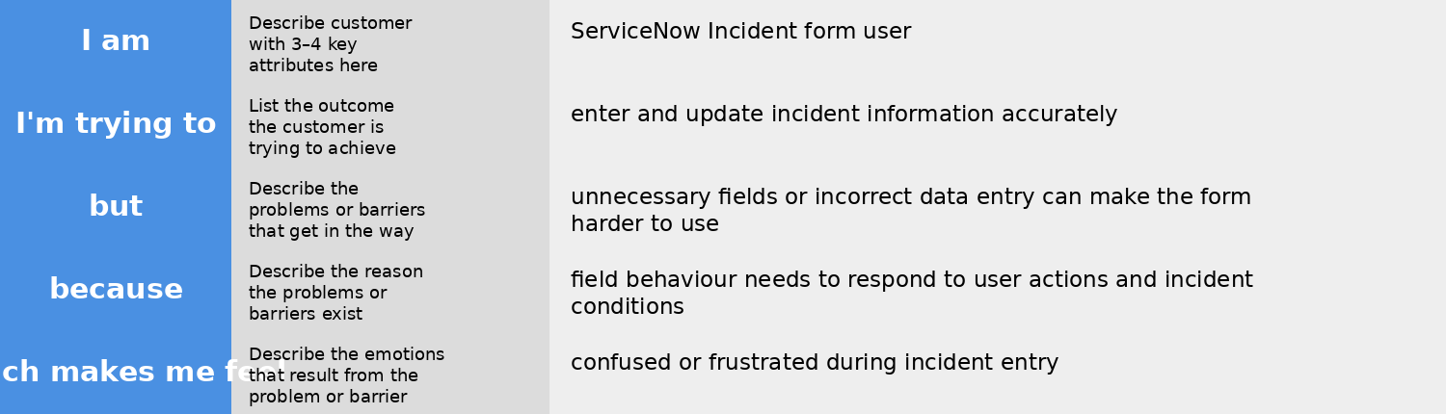
Reference: https://miro.com/templates/customer-problem-statement/
Example:
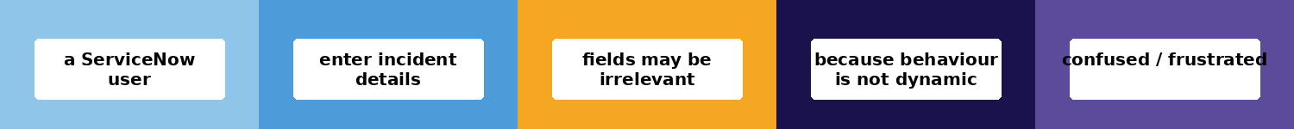

Problem  Statement (PS) | I am  (Customer) | I’m trying to | But | Because | Which makes me feel
PS-1 | a ServiceNow Incident form user | enter and update incident information accurately | the form may show unnecessary fields or allow incorrect data entry | field behaviour needs to change based on user actions and incident conditions | confused when entering incident details
PS-2 | an IT service desk user | complete an Incident record efficiently | the form does not dynamically guide field behaviour before submission | Client Scripts and UI Policies can control fields dynamically | frustrated by extra effort and unclear field behaviour

